**Viewing and Downloading Reports for the October 1 Consolidated Report**



1. Log on to the WAVE portal
2. On the top portion of the page, click Reporting>State Reporting Certification

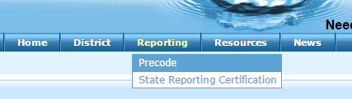

1. Scroll to the bottom portion of the screen and click the link to October 1 Consolidated Report

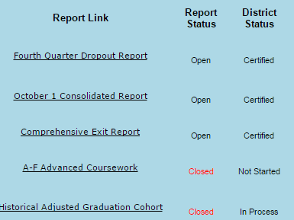

1. Click on any site name

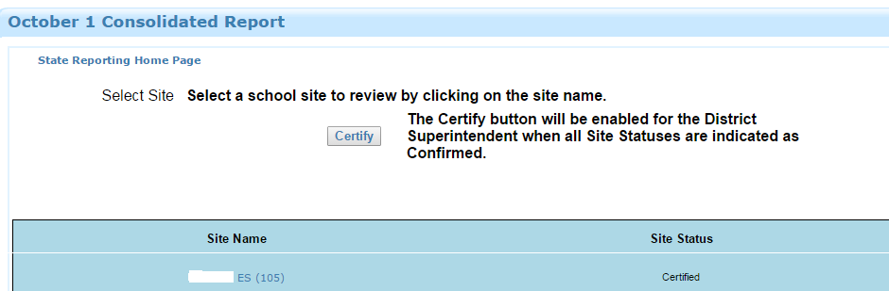

1. Click on Reporting Tools

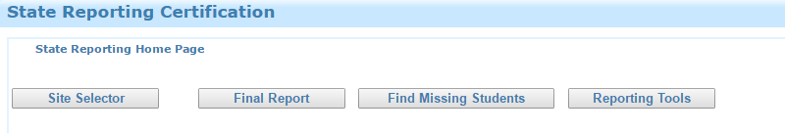

1. Select the Oct 1 Student Demographic Report. Just to the right of the Site box there is the option of District Report--check that. Click View Report

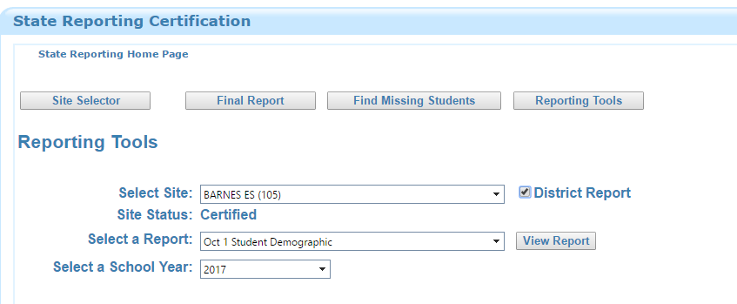

1. The report will open in another tab. At the very top there will be a diskette icon that has a drop down that you can select what kind of export you want

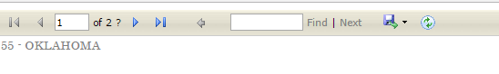

1. Click the .csv button to download your file.

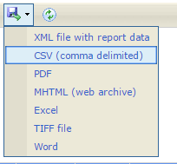

1. Save the .csv file and email it to EduSkills’ personnel for data comparison.